Module 54
Chatfield Senior High School
Dimensional Changes and Modifications: April 18, 2015

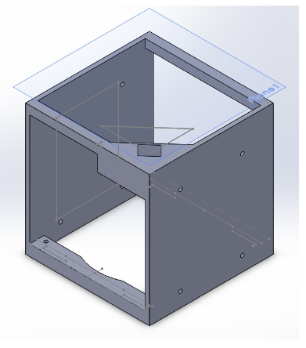
In order to provide a second level of containment it became necessary to decrease the size of our bioreactor and resize our inner box. This allows for a polycarbonate cover on our inner box that allows room for the camera extending from the NESI.

Upper Supports

Motor Holder

Bottom Support
Figure 1

Motor above cover
Three other dimensional changes to the design include resizing the
upper supports to provide additional structural strength. The motor holder has been changed to better hold the motor in place and the depth adjusted to allow the motor to protrude from this level, above the top cover (see Fig 2). This change allows us to have our cover below the lens of the camera, and will provide some protection for the motor in the event of a leak, as the motor will be almost entirely outside of the inner box. The opening at the bottom of the holder through which the drive shaft extends could allow a small amount of liquid to contact the motor, but will not allow liquid out of this level as the perimeter of the motor will be sealed around the top cover using our aquarium caulk. The bottom supports have also been increased in depth to allow the nuts on the bolts which hold the bioreactor together freedom to spin as they Figure 2
extend below the bioreactor.

In addition to the size changes, the loss of height has necessitated a change of location for the battery holder and the MOSFET. The upper holes in Fig 2 are used for screws to support the top bracket that holds our rollers in place and the bottom holes used for the bottom bracket. The new battery location will be next to the bioreactor in the lower section
(shown in green in Fig 3). This will require a very
slight modification to the dimensions of the battery
holder. It will be made slightly slimmer and a little
bit taller. It will still hold 8 batteries in parallel and top bracket
will be wired to the MOSFET to drain the batteries
upon power-up in the NanoRack. The MOSFET will
be secured to the inner box (shown in purple in Fig3).
Wiring from the battery will extend out of the box
(sealed with caulk) and along the sides to copper tape Bioreactor
running to light locations on the inner box.

Support Roller
Motor Roller Battery holder

MOSFET

bottom bracket

Figure 3

We have formalized our plan for the light placement for transit to orbit. We plan to have the LEDs project into the inner box through the sides, allowing copper tape to run on the outside of the box and connect to the lights (orange in Fig 4). The LEDs will connect to the copper tape for power and the tape will be connected to the battery through holes in the inner box (all sealed with caulk to maintain the containment). The tape will extend to the other side of the box for LEDs on that side.

Figure 4

The LEDs will be connected to the inner box by drilling holes and inserting the lights into the inner box above the bioreactor. They will be directed downward into the chambers of the bioreactor as shown by the red circles in Fig 5. The LEDS will extend into the inner box above the top bracket (Fig 3).
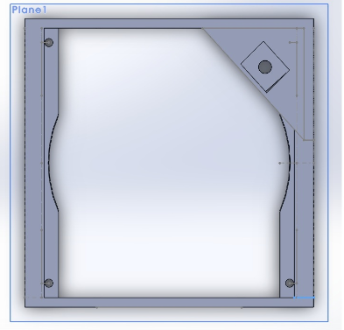

Figure 5

